📘 CONSOLE-BASED LIBRARY MANAGEMENT SYSTEM
Command-Line Application Project

Submitted by:
Dhanalakshmi konduru
Role: Full Stack Java Developer
Technologies: Java, OOP, File I/O

🟦 1. Project Overview
The Library Management System is a console-based application designed to help librarians efficiently manage books, members, and borrowing operations. It emphasizes object-oriented programming principles, file-based data persistence, and robust user input validation.
The application provides a user-friendly menu-driven interface for performing all essential library operations.

🟦 2. Project Description
A Java console application that allows librarians to:
- Add, remove, and search for books
- Register and manage library members
- Borrow and return books with due dates
- Track overdue books and fines
- Generate library statistics
Data persistence is implemented using text files (books.txt and members.txt) to ensure records are saved between sessions.

🟦 3. Project Objectives
- Implement a functional library management system in Java
- Apply OOP concepts such as classes, encapsulation, and inheritance
- Handle persistent data using File I/O
- Provide a clear, menu-driven console interface
- Ensure input validation and exception handling
- Maintain a modular and organized code structure

🟦 4. Features
- Add new books and remove existing books
- Search books by title, author, or ISBN
- Register new members and manage their borrowed books
- Borrow and return books with due date tracking
- Calculate overdue fines automatically
- Display library statistics: total books, available books, borrowed books, overdue books, registered members
- File-based data persistence for books and members

🟦 5. Technologies Used
- Java – Core programming language
- Object-Oriented Programming (OOP) – Classes, encapsulation, constructors
- File I/O – Reading/writing data to text files
- ArrayLists – Storing collections of books and members
- Console-based Menu System – User interface
- Exception Handling – Input validation and error handling

🟦 6. Setup and Installation Instructions
- Install Java JDK (version 8 or above)
- Create the folder structure:
week3-library-system/
│── src/main/java/library/
│── data/
- Copy Java files (Main.java, Book.java, Member.java, Library.java, FileHandler.java) to src/main/java/library/
- Create empty data files in data/:
books.txt
members.txt
- Open CMD, navigate to project root:
cd path\to\week3-library-system
- Compile Java files:
javac -d bin src\main\java\library\*.java
- Run the program:
java -cp bin library.Main

🟦 7. Code Structure Explanation
Folder/File | Description
src/main/java/library/ | Contains all Java source code files
Main.java | Main class with menu and program flow
Book.java | Book class with properties and methods
Member.java | Member class to manage library members
Library.java | Manages books and members, borrowing logic
FileHandler.java | Handles file reading/writing for persistence
data/books.txt | Stores book records
data/members.txt | Stores member records

🟦 8. How to Use
- Run the program using CMD.
- Follow the menu options:
1. Add Book
2. View All Books
3. Search Books
4. Register Member
5. Borrow Book
6. Return Book
7. View Library Statistics
8. Exit
- Enter your choice number and follow prompts.
- Data changes are automatically saved in books.txt and members.txt.

🟦 9. Key Technical Requirements Met
- Object-oriented design with Book, Member, and Library classes
- File I/O for data persistence
- ArrayLists for dynamic storage of books and members
- Console-based menu-driven user interface
- Input validation and exception handling
- Search and filter functionality for books
- Borrowing and returning with due date tracking

🟦 10. Screenshots of Working Application
=== LIBRARY MANAGEMENT SYSTEM ===
- Add New Book
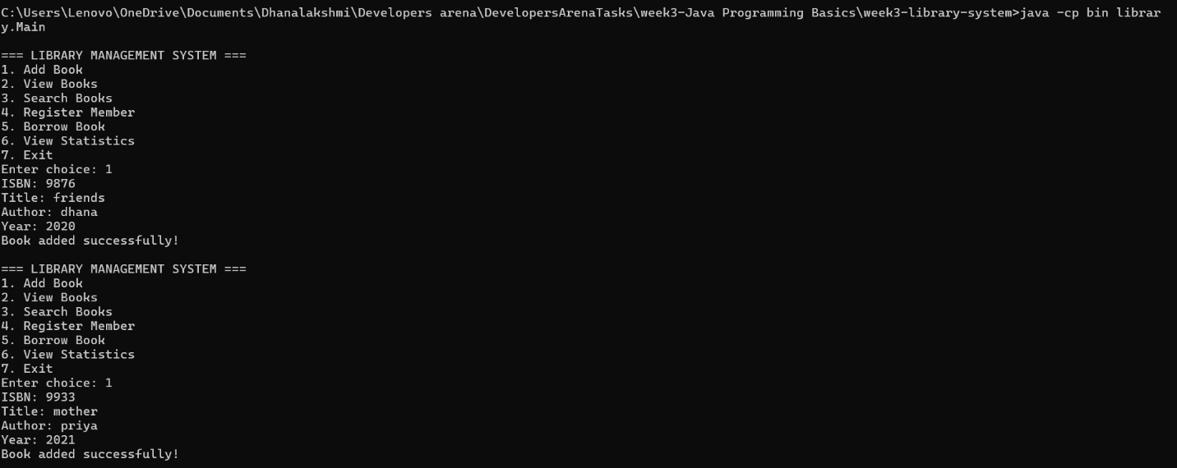
- View All Books
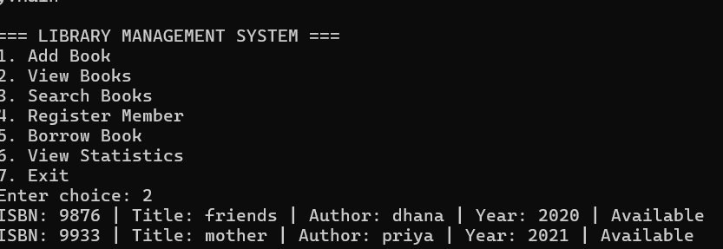
- Search Books
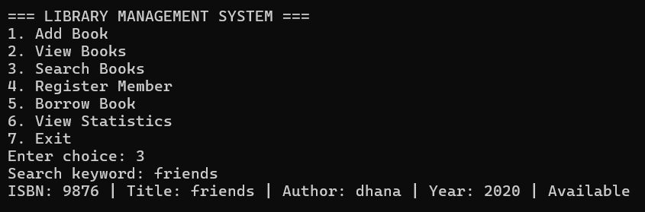
- Register Member
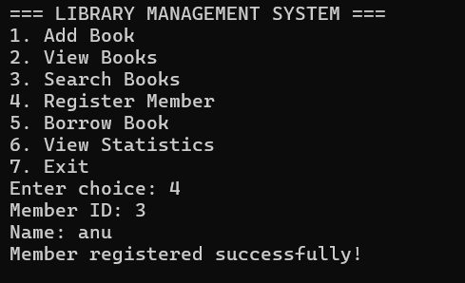
- Borrow Book
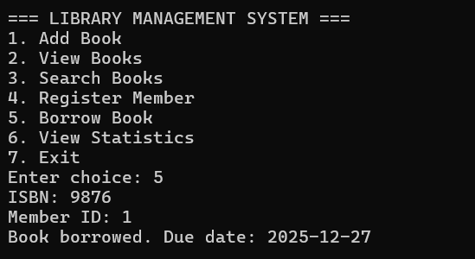

- View Library Statistics
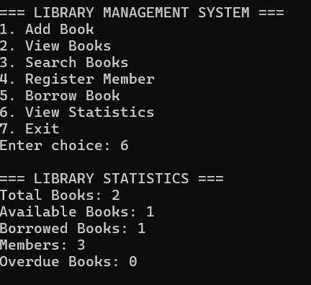
- Exit
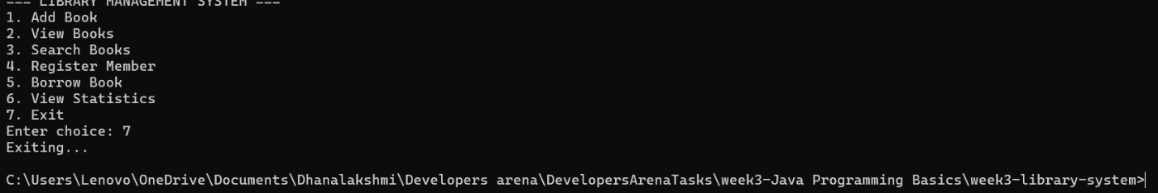

🟦 11. Conclusion
This project demonstrates a functional and modular Library Management System built with Java. It fulfills all the project requirements, applies OOP concepts, ensures data persistence, and provides a clear console interface for library operations.

